花岗石检测平台 Granite Inspection Plate
Specifications  规格 | Plateness Tolerance (μm) 平面度公差 |  |  |  | After-Packing  VOL (mm)  包装后体积 | Weight  (kg)重量
Specifications  规格 | Grade 000 | Grade 00 | Grade 0 | Grade 1 | After-Packing  VOL (mm)  包装后体积 | Weight  (kg)重量
160x100x50 | 0.8 | 1.5 | 3 | 6 | 270x210x150 | 8
160x160x50 | 0.8 | 1.5 | 3 | 6 | 270x270x150 | 9
250x160x50 | 0.9 | 1.8 | 3.5 | 7 | 370x270x150 | 11
250x250x50 | 0.9 | 1.8 | 3.5 | 7 | 370x370x150 | 13
300x200x50 | 0.9 | 1.8 | 3.6 | 7 | 410x270x180 | 15
300x300x70 | 1 | 1.9 | 3.8 | 7.5 | 410x370x200 | 27
400x250x70 | 1 | 2 | 4 | 8 | 510x470x200 | 30
400x400x70 | 1.2 | 2.3 | 4.5 | 9 | 528x488x210 | 46
630x400x100 | 1.3 | 2.5 | 5 | 10 | 740x490x270 | 94
630x630x100 | 1.3 | 2.5 | 5 | 10 | 750x730x270 | 155
800x500x100 | 1.4 | 2.7 | 5.3 | 11 | 920x600x280 | 155
900x600x100 | 1.5 | 2.9 | 5.7 | 11.5 | 1000x660x200 | 200
1000x630x150 | 1.5 | 3 | 6 | 12 | 1120x740x330 | 335
1000x750x150 | 1.6 | 3.2 | 6.3 | 12.5 | 1250x950x330 | 398
1000x1000x150 | 1.8 | 3.5 | 7 | 14 | 1250x1230x330 | 532
1600x1000x200 | 2 | 4 | 8 | 16 | 1870x1230x370 | 1080
1600x1600x200 | 2.4 | 4.8 | 9.5 | 19 | 1870x1830x370 | 1730
2000x1000x200 | 2.4 | 4.8 | 9.5 | 19 | 2270x1230x400 | 1345
2000x1600x250 | 2.5 | 5 | 10 | 20 | 2310x1830x460 | 2622
2500x1600x300 | 2.9 | 5.8 | 11.5 | 23 | 2810x1830x510 | 3872
3000x2000x400 | 3.3 | 6.5 | 13 | 27 | 3350x2230x670 | 7651

华安精密花崗石平板精度參照各先進國家標準,平面度公差依:JB/T7975-1999標準，或德国标准或美国实验室标准。精度等级如下：
000級=1×(1+d/1000)μm
00級=2×(1+/1000)μm
0級=4×(1+d/1000)μm
1級=8×(1+d/1000)μm
(d為對角線mm)
(測量溫度一般在20±2°C)
花崗石平板精度表见上页。

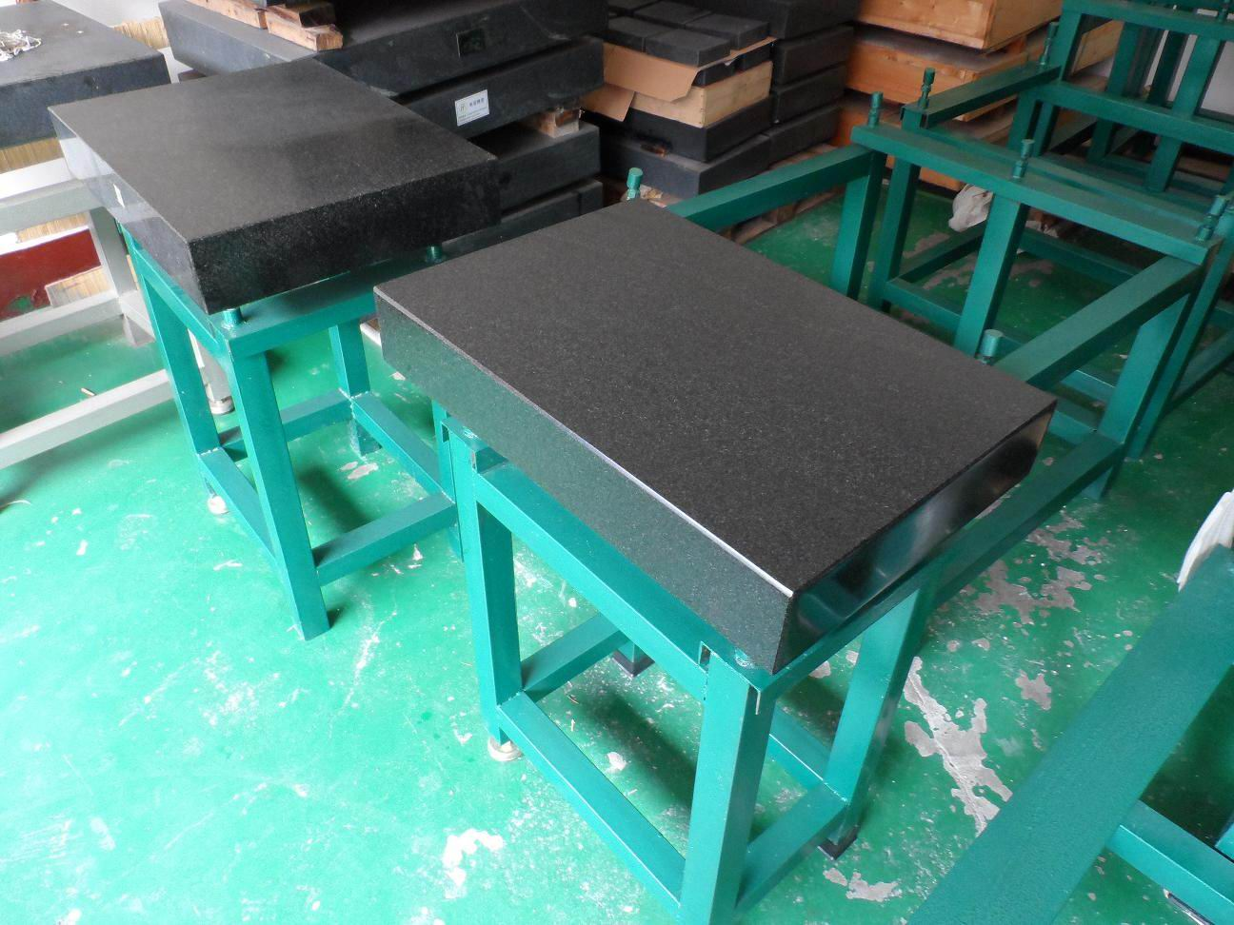

备注(Notes): 规格Specifications (mm);精度等级Precision grade 000级：平面度Grade 000 flatness(μm)00级;平面度Grade 00 Flatness(μm) 0级;平面度Grade 0 Flatness(μm)1级;平面度Grade 1 Flatness(μm) ;Net 净重kg

