Vernier calipers with tables
First, the product performance is as follows:
-  The resolution is 0.01mm, and it is very easy to obtain accurate data;
-  Calipers of power by means of amplification devices of rack and pinion;
-  Yellow analogue dial, easy to read;
-  The pointed measuring jaw is easy to measure the narrow part of the workpiece;
-  The material is R13 high-carbon steel C: 0.95%-1.05%, Si: 0.15%-0.35%, Mn: 0.25%-0.45%, Cr: 1.40%-1.65%, Ps: 0.025%, P, S≤0.0025% high-carbon steel material, hardness is greater than 60HRC, its stability is good, no rust, wear-resistant, the ruler frame can maintain smooth movement, comfortable operation;
The second， measurement function is as follows:
- Outer diameter measurement; (2) Inner diameter measurement; (3) depth measurement; (4) Ladder measurement.
The third plane figure and the size specification

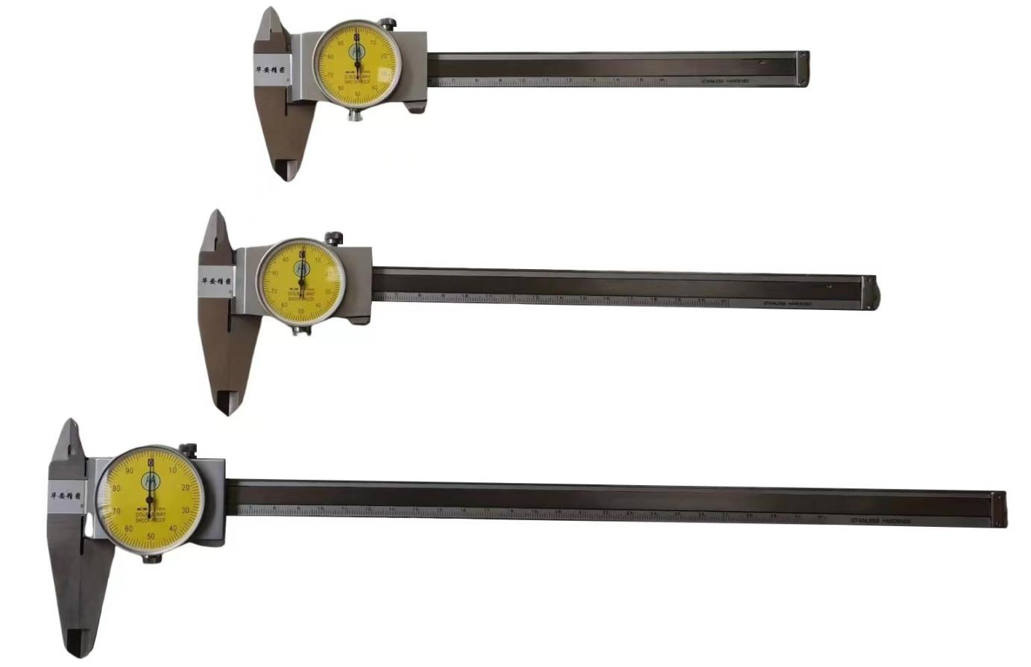

Fourth, the measurement range and accuracy
Resolution and accuracy: The resolution is 0.01 mm, and the accuracy level varies slightly depending on the range, as shown in the table below:
NO | range | resolution | tolerance（+/-） | Weight(g) | A | B | C | D | H | L
2204 | 0-150 | 0.01 | 0.02 | 168 | 16.5 | 21 | 14.6 | 40 | 16 | 233
2205 | 0-200 | 0.01 | 0.02 | 198 | 20 | 24.5 | 18.1 | 50 | 16 | 290
2206 | 0-300 | 0.01 | 0.03 | 350 | 22 | 27.5 | 19.8 | 64 | 20 | 404
Warning 2: The outer claws are sharp, and it is important to pay attention to safety when using them to prevent scratches, especially for children, and they need to be used under the strict supervision or guidance of adults.
Warning 3: Vernier calipers are more precise measuring tools, and should be handled with care, and should not be bumped or dropped to the ground. Do not use it to measure rough objects when in use, so as not to damage the measuring jaw, and put it in a dry place to prevent rust when not in use.

