Perpendicularity altimeter
- The fixation of the clamp can be carried out easily and stably.
- A dial indicator can be fixed on the side to measure the perpendicularity.
- The height measurement in the up-down direction is read with the help of a gauge at the graduation line.
- The driving handwheel can be easily adjusted coarsely.
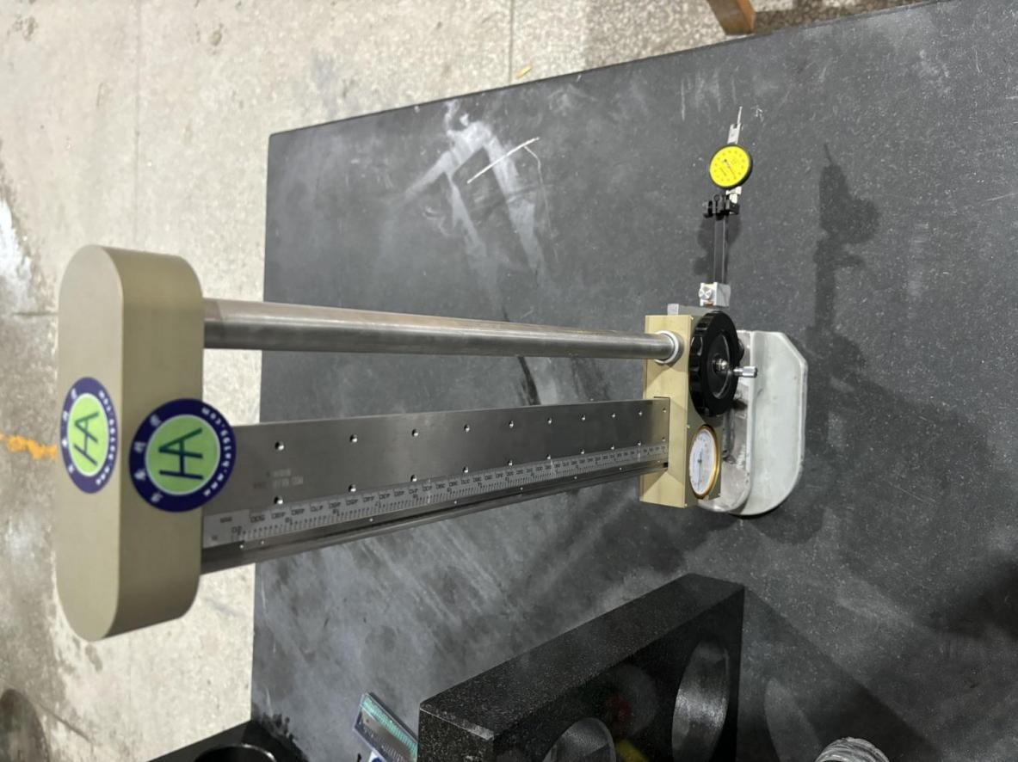

specification
Model | Measuring rang（mm） | Graduated Value（mm） | height measurement（mm） | Verticality Measurement（mm） | Height（mm） | Mass（kg）
HA-GUC-1 | 0-450 | 0.02 | ±0.03 | ±0.003 | 1000 | 9.8
- Among them, it is mainly used in THK's ssss-level high-precision guide rail (the accuracy of the guide rail is up to 2（μm）。
- The back material is: 4CR13 material.
- Meter head: its measurement accuracy is plus or minus 0.03, which is no different from a large stroke caliper.
- Pure mechanical structure, long service life.
- Tips: Can not be in contact with water stains for a long time, you can add some lubricating oil to prolong the life.

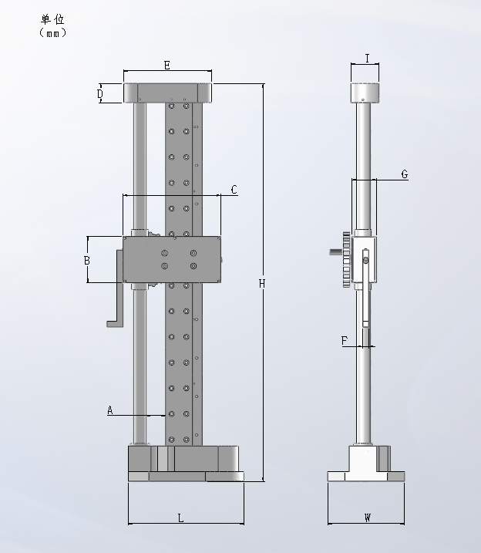

Size

Model | A | B | C | E | F | G | H | I | L | W
HA-GUC-1 | 30 | 72 | 152 | 137 | 9 | 39 | 619.8 | 44 | 180 | 120

Directions for use
- Base: The base is in the shape of a composite one-handed support, which can be moved smoothly with one hand.
- Handwheel: The upper and lower positions can be adjusted by moving smoothly. L-shaped fixture device: different gauges, scribes, etc. can be installed according to the actual situation.
- cale bar: Observe the data on the scale to see the specific height. Meter head: Observe the meter head, each grid is 0.02mm, and further measure the height data with the scale reading.

