比测台，千分表测量台 Granite inspection plate Granite plate

Granite Inspection Plate with the best and stable flatness according to standard of DIN/JIS/GB could supply as the following（本公司能够依据中国、德国和美国实验室标准生产如下
规格的比测台）
Specifications : Types | measuring height(mm) | overall dimension (mm) |  | Remark | weight/unit (kg)
Specifications : Types | measuring height(mm) | base | column | Remark | weight/unit (kg)
SZ150x100 | 0-100 | 150x100x50 | Æ 18x150 | with vernier devic | 4
SZ200x150 Type A | 0-250 | 200x150x50 | Æ35x300 | with vernier devic | 6.7
SZ200x150 TYPE B | 0-250 | 200x150x50 | Æ35x300 | with vernier device | 6.9
SZ300x200 TYPE B | 0-250 | 300x200x50 | Æ35x300 | with vernier device | 12.4
SZ300x200 TYPE C | 0-250 | 300x200x50 | Æ35x300 | with cantilever | 12.6
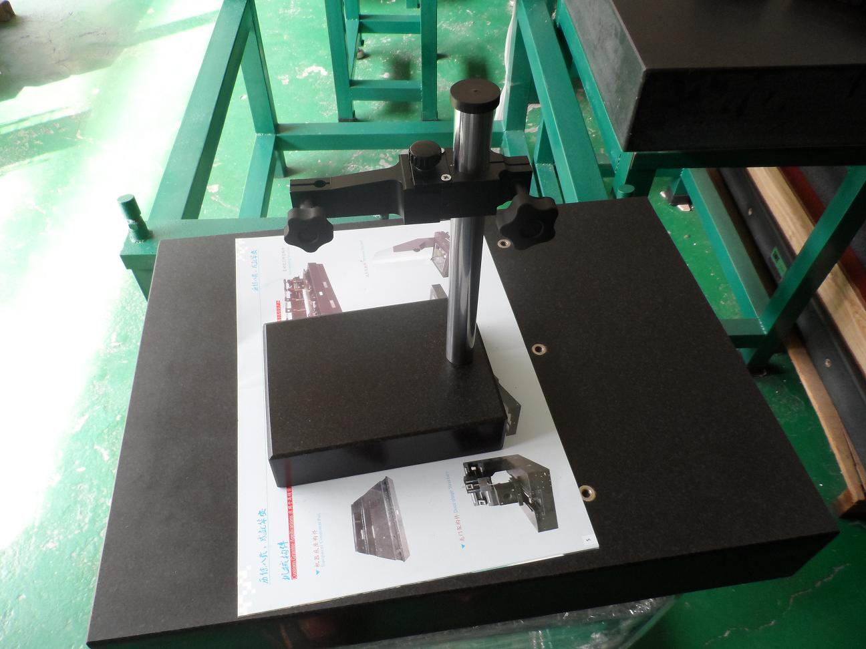
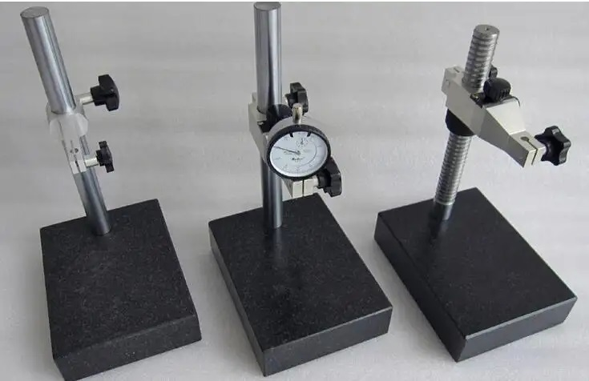

备注(notes): 规格specifications (mm);精度等级Precision grade 000级;平面度Grade 000 flatness(μm)00级平面度Grade 00 flatness(μm) 0级;平面度Grade 0 flatness(μm)1级;平面度Grade 1 flatness(μm) ;净重kg

